Command prompt notes:

1. cd = change directory

Eg: cd desktop

1. mkdir = make directory
2. cd .. = go back to the previous folder
3. dir = show the directory in that current folder

- for mac : ls

1. For macbook long argument (must insert string)

- cd “OneDrive - Universiti Teknikal Malaysia Melaka”

1. help= to show all the command that can use
2. rmdir = to delete a folders

- del can’t be used

1. git init = initialized empty git repository to synchronize with cloud

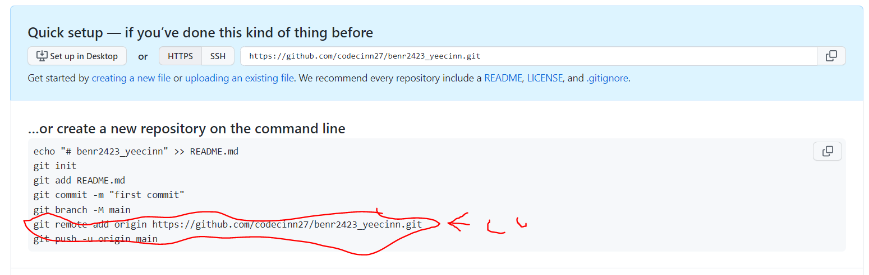

Copy this to the cmd prompt

#git remote -v

# to check whether the process is successfully install or not

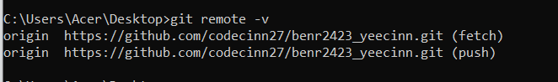

Go to visual studio code

#type npm init

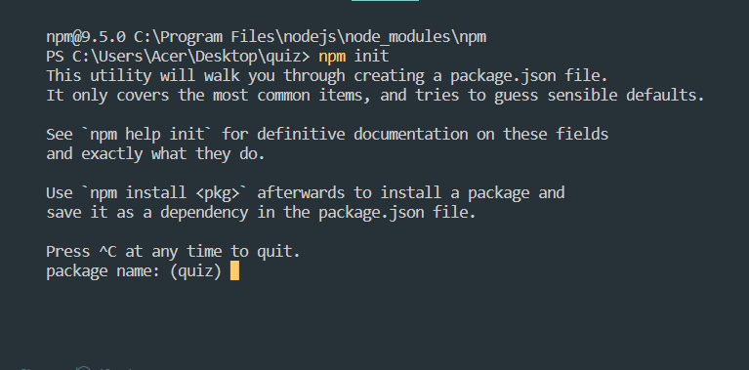

# press enter all the way

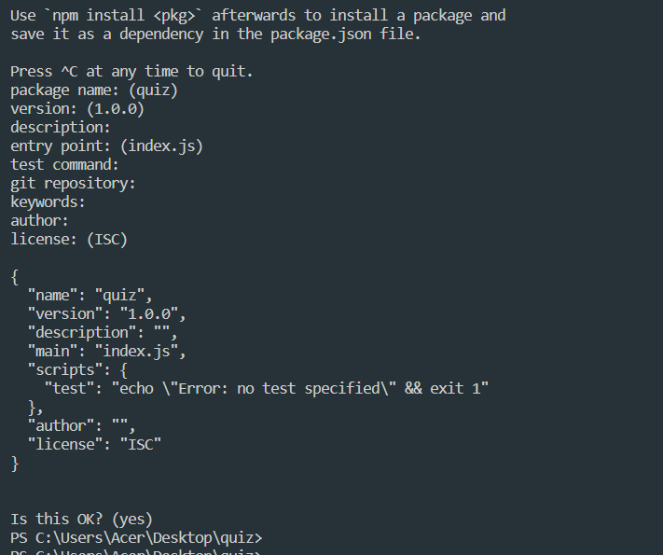

# then you will obtain a json file

- git add .

- git commit -m” write anything you like”

- git push -u origin main

1. dir /a

- to show all the hidden file

1. change from local disk C to local disk D

- D:

- C: